**IT2120 - Probability and Statistics**

**Gangoda E.W.W.M.C.R.B**

**IT24100119**

**Lab Exercise 9**

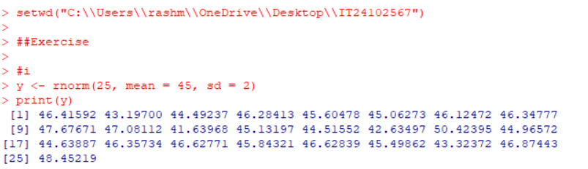**1.**

**2.**